**Description of Diagrams**

1. **Overall System Flowchart**: This flowchart provides a high-level view of the continuous video processing loop, from capturing frames to processing and displaying them, including the decision points for exiting the program.
2. **flowchart** TB
3. A[Start] **-->** B[Capture Frame from Video Feed]
4. B **-->** C[Check Frame Availability]
5. C **-->**|Frame Available| D[Process Frame]
6. C **-->**|Frame Not Available| G[End]
7. D **-->** E[Remove Rain]
8. E **-->** F[Remove Fog]
9. F **-->** H[Display Processed Frame]
10. H **-->** I{Exit?}
11. I **-->**|Yes| G[End]
12. I **-->**|No| B[Capture Next Frame]

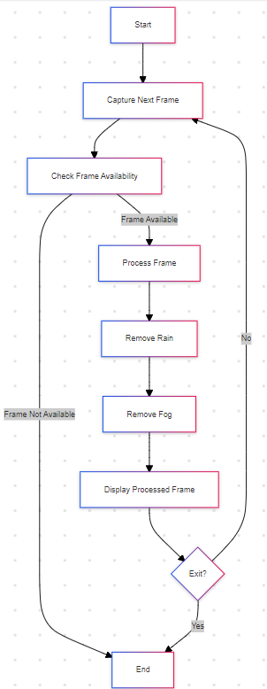

1. **Rain Removal Process**: Focuses on the specific steps taken to detect and remove rain streaks using image processing techniques like thresholding, morphological operations, and inpainting.
2. **flowchart** TD
3. A[Remove Rain] **-->** B[Convert to Grayscale]
4. B **-->** C[Apply Median Blur]
5. C **-->** D[Thresholding to Detect Rain Streaks]
6. D **-->** E[Apply Morphological Operations]
7. E **-->** F[Create Rain Mask]
8. F **-->** G[Inpaint Original Frame Using Rain Mask]
9. G **-->** H[Output Rain-Free Frame]

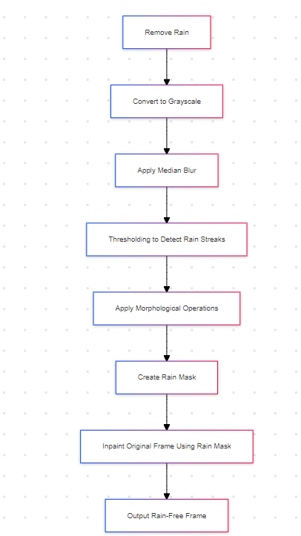

1. **Fog Removal Process**: Describes the process of enhancing foggy frames by converting to YCrCb color space, applying histogram equalization to the luminance channel, and converting back.
2. **flowchart** TD
3. A[Remove Fog] **-->** B[Convert to YCrCb Color Space]
4. B **-->** C[Split Channels]
5. C **-->** D[Equalize Histogram of Y Channel]
6. D **-->** E[Merge Channels]
7. E **-->** F[Convert Back to BGR]
8. F **-->** G[Output Fog-Free Frame]

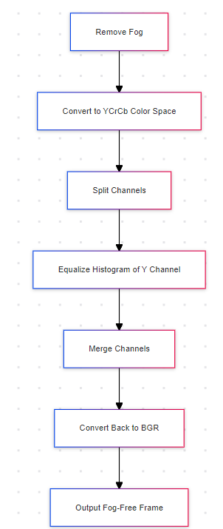

1. **Detailed Frame Processing**: Integrates the rain and fog removal processes to show the complete path of how a frame is handled by the system.
2. **flowchart** TD
3. A[Process Frame] **-->** B[Remove Rain]
4. B **-->** C[Remove Fog]
5. C **-->** D[Return Processed Frame]
6. **subgraph** Rain Removal
7. B1[Convert to Grayscale] **-->** B2[Apply Median Blur]
8. B2 **-->** B3[Thresholding]
9. B3 **-->** B4[Morphological Operations]
10. B4 **-->** B5[Inpainting]
11. B5 **-->** B6[Rain-Free Frame]
12. **end**
13. **subgraph** Fog Removal
14. C1[Convert to YCrCb] **-->** C2[Split Channels]
15. C2 **-->** C3[Equalize Histogram]
16. C3 **-->** C4[Merge Channels]
17. C4 **-->** C5[Fog-Free Frame]
18. **end**

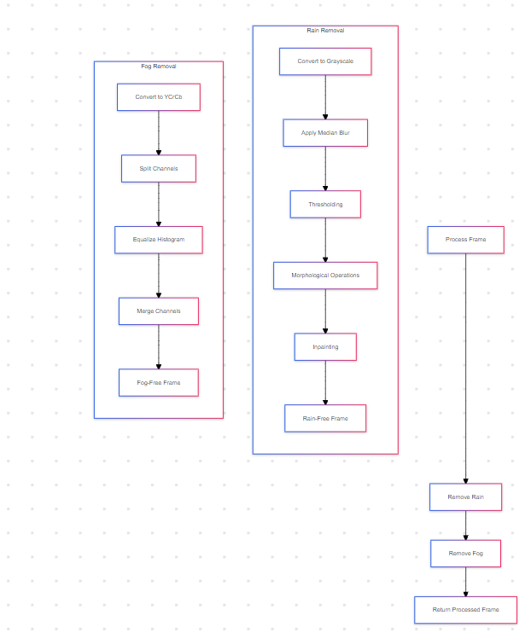

1. **System Architecture Diagram**: Illustrates the flow of data between different modules of the system, providing an overview of the architecture and how each component interacts.
2. **graph** LR
3. Camera[Camera Input] **-->** Processing[Processing Module]
4. Processing **-->** RainRemoval[Rain Removal Algorithm]
5. RainRemoval **-->** FogRemoval[Fog Removal Algorithm]
6. FogRemoval **-->** Display[Display Processed Feed]
7. Display **-->** User[User Interaction]
8. **subgraph** Processing Module
9. RainRemoval
10. FogRemoval
11. **end**

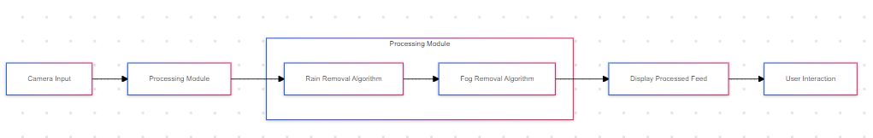

**6. Sequence Diagram**

**sequenceDiagram**

    participant User

    participant Camera

    participant Processor

    participant RainRemoval

    participant FogRemoval

    participant Display

    User **->>** Camera: Start Video Feed

    Camera **->>** Processor: Capture Frame

    Processor **->>** RainRemoval: Remove Rain from Frame

    RainRemoval **->>** Processor: Return Rain-Free Frame

    Processor **->>** FogRemoval: Remove Fog from Frame

    FogRemoval **->>** Processor: Return Fog-Free Frame

    Processor **->>** Display: Send Processed Frame

    Display **->>** User: Show Processed Frame

    User **->>** Display: Check Exit Condition

    Display **->>** User: Exit? (Yes/No)

**alt** User Exits

        User **->>** Camera: Stop Video Feed

        Camera **->>** Processor: Stop Processing

        Processor **->>** Display: Close Display

**else** User Continues

        Display **->>** Camera: Capture Next Frame

        Camera **->>** Processor: Continue Processing Loop

**end**

